Tasks for Docker-01.
1) Setup a virtual machine using Ubuntu image.

Step 1: Login to AWS
Go to 👉 Amazon Web Services Console
- Open EC2 Dashboard

Step 2: Launch Instance
- Click “Launch Instance”

Step 3: Choose Ubuntu Image
- In Application and OS Images (AMI)
- Select 👉 Ubuntu Server (latest LTS recommended, e.g., 22.04)

Step 4: Choose Instance Type
- Select:
  - t2.micro (Free Tier eligible)
Step 5: Create Key Pair
- Click Create new key pair
- Choose:
  - Type: RSA
  - Format: .pem
- Download and save it safely (important for SSH)

Step 6: Configure Network Settings
- Allow:
  - ✅ SSH (Port 22)
  - (Optional) HTTP (80), HTTPS (443)

Step 7: Configure Storage
- Default: 8 GB (you can increase if needed)

Step 8: Launch Instance
- Click Launch Instance
- Wait until status = Running
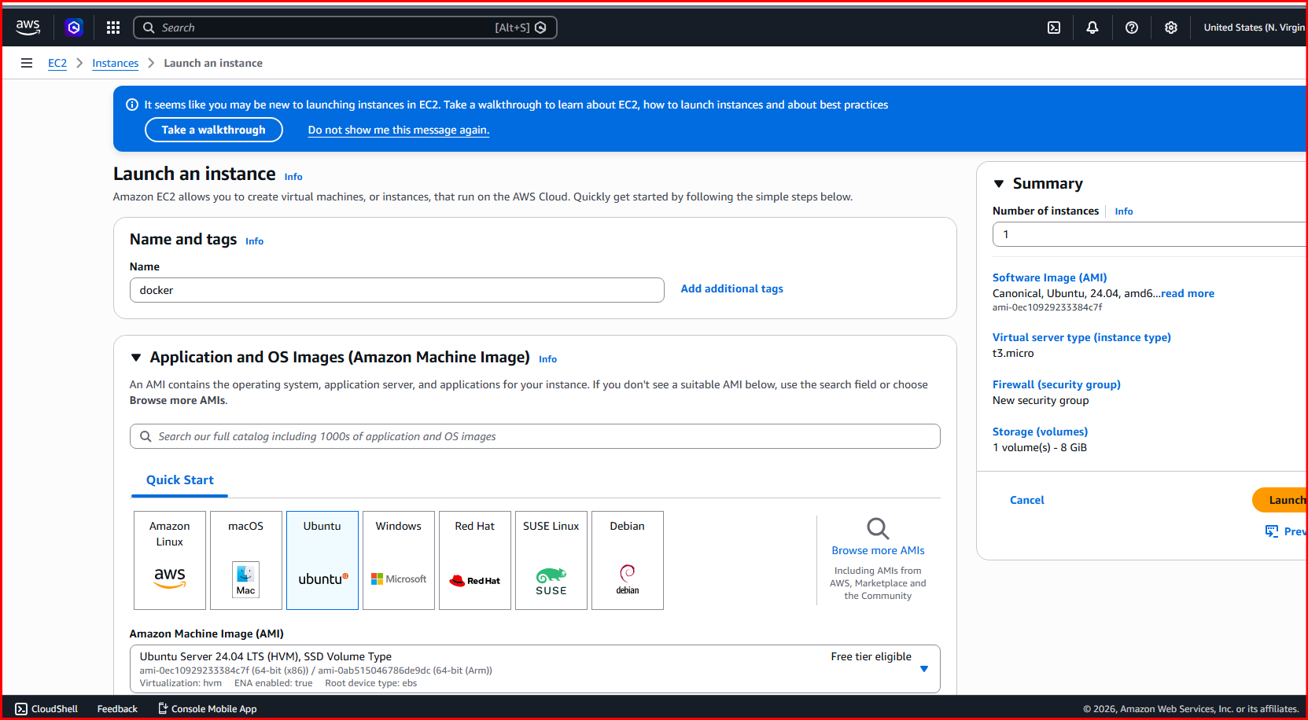
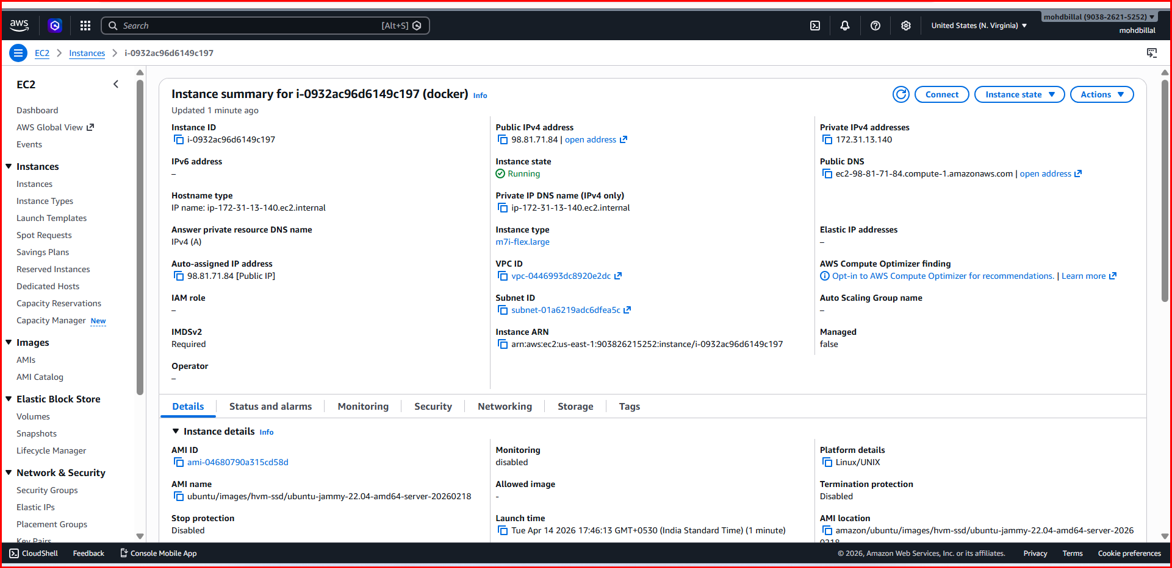
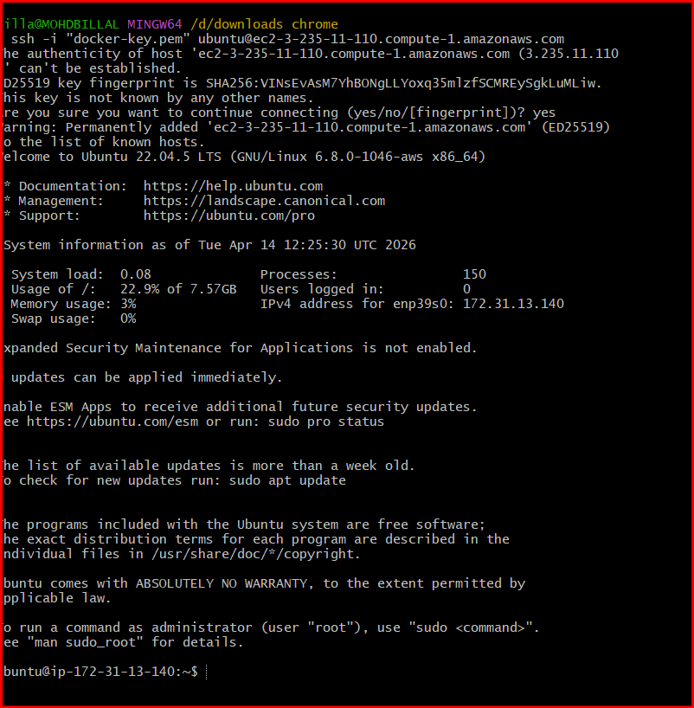

Step 9: Connect to EC2 (SSH)
Open terminal and run:
chmod 400 your-key.pem
ssh -i your-key.pem ubuntu@<your-public-ip>

Step 10: Update System
After login:
sudo apt update
sudo apt upgrade -y

Done!
Now your Ubuntu virtual machine is ready.
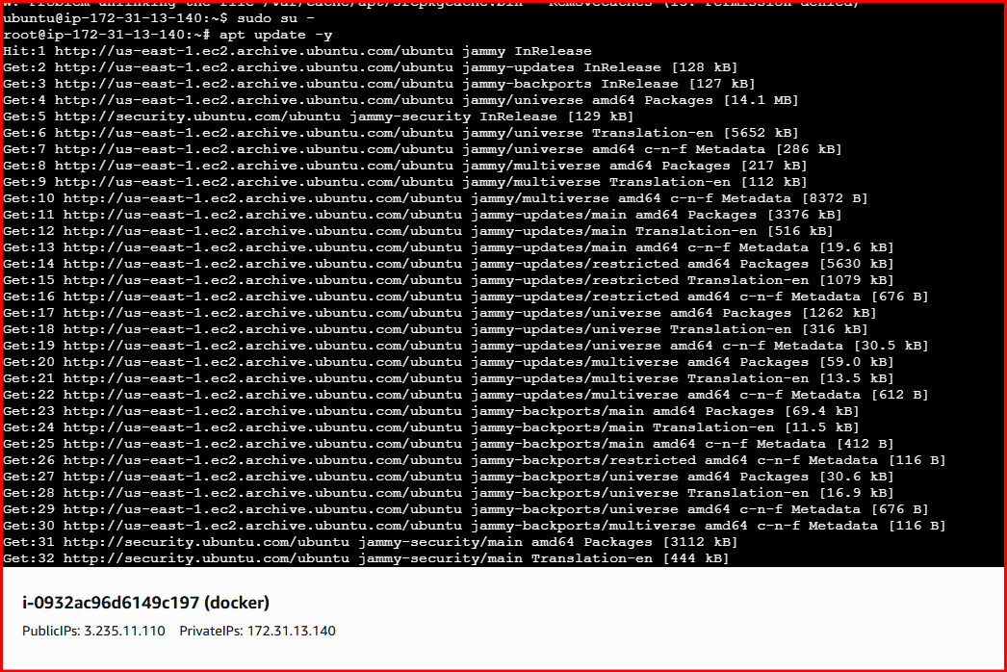

2) Install docker on ec2.

Install Docker
sudo apt install docker.io -y
sudo systemctl start docker
sudo systemctl enable docker
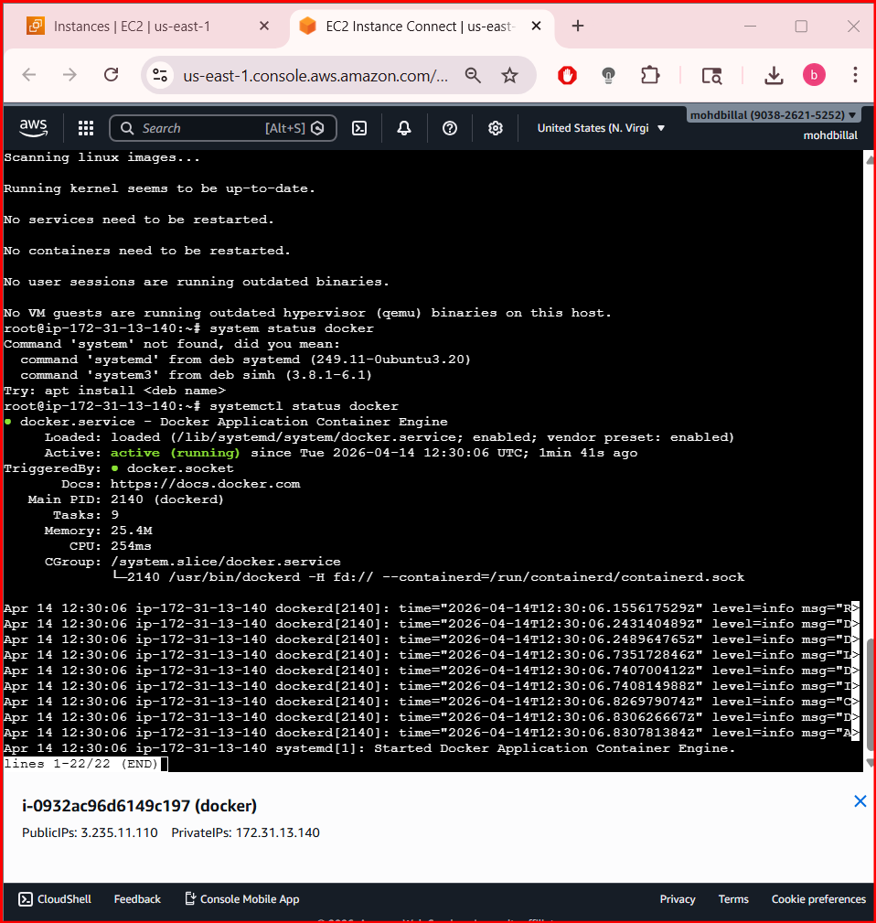

3) Pull 5 docker images.(nginx,apache tomcat,ubuntu,jenkins,sonarqube)

1. Pull NGINX
sudo docker pull nginx

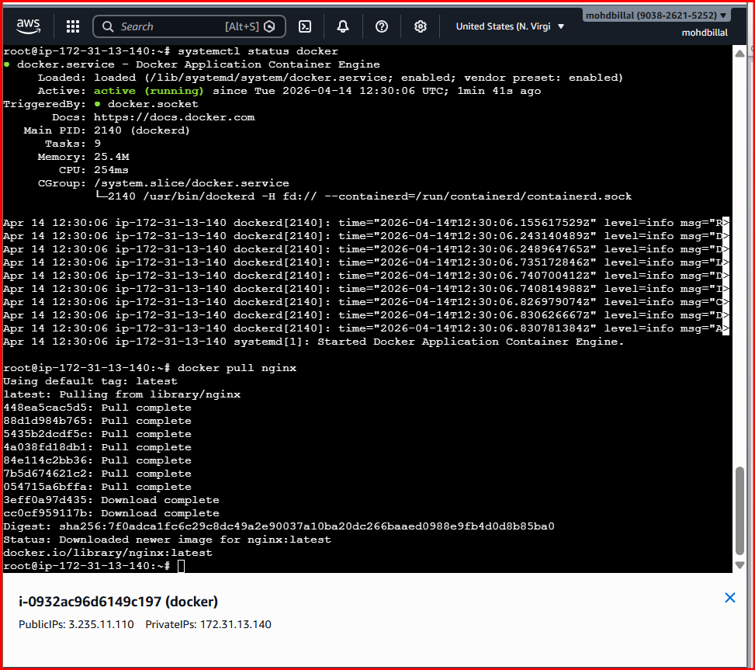

- sudo docker pull tomcat

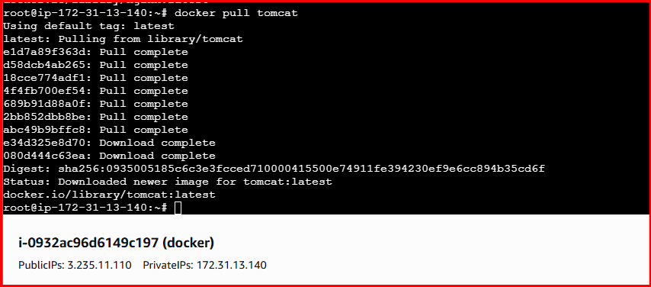
- sudo docker pull ubuntu

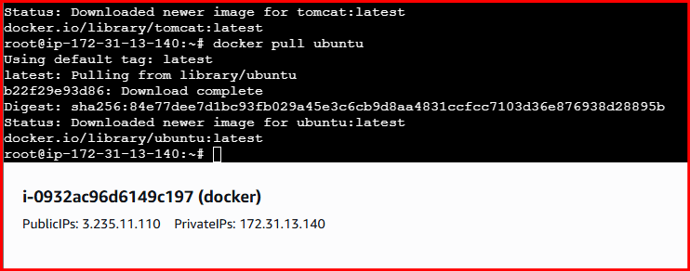
- sudo docker pull sonarqube

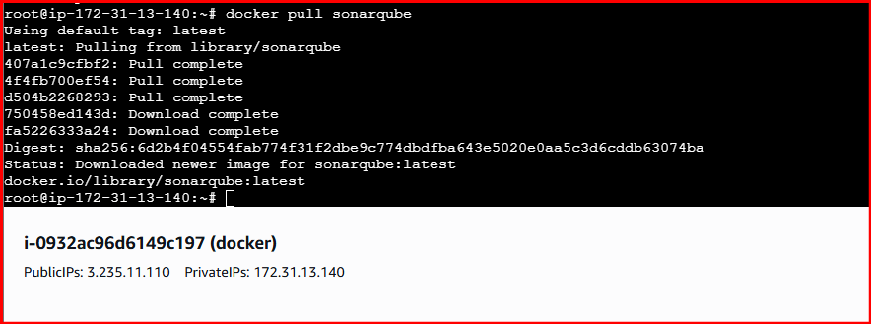
- sudo docker pull Jenkins/Jenkins:lts

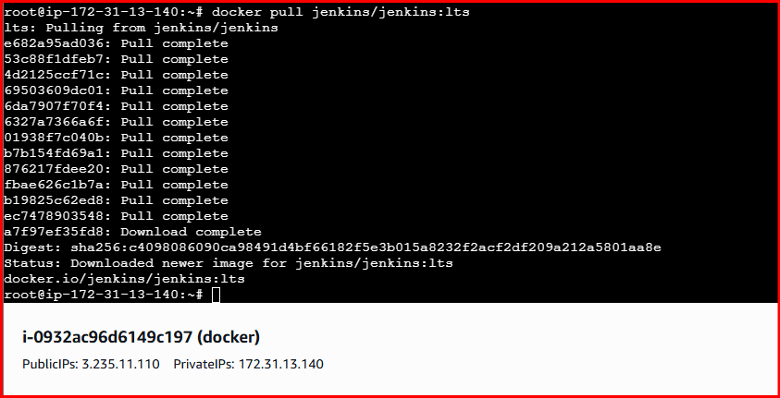
- Validating all images using docker images command

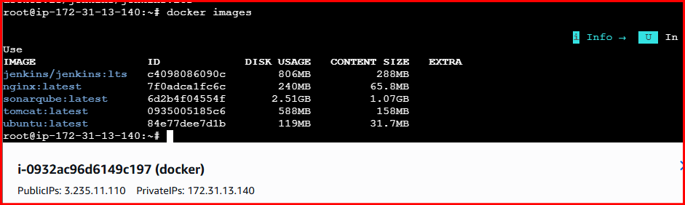
4) Run nginx container and expose on port 81.

- Run nginx container and expose on port 81:80
- Use the command docker run -itd -p 81:80 nginx command to run the nginx server and also on 81 port number

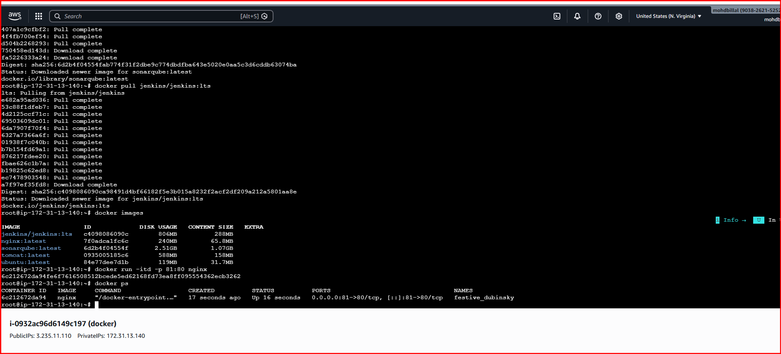
Use the command docker ps to running containers

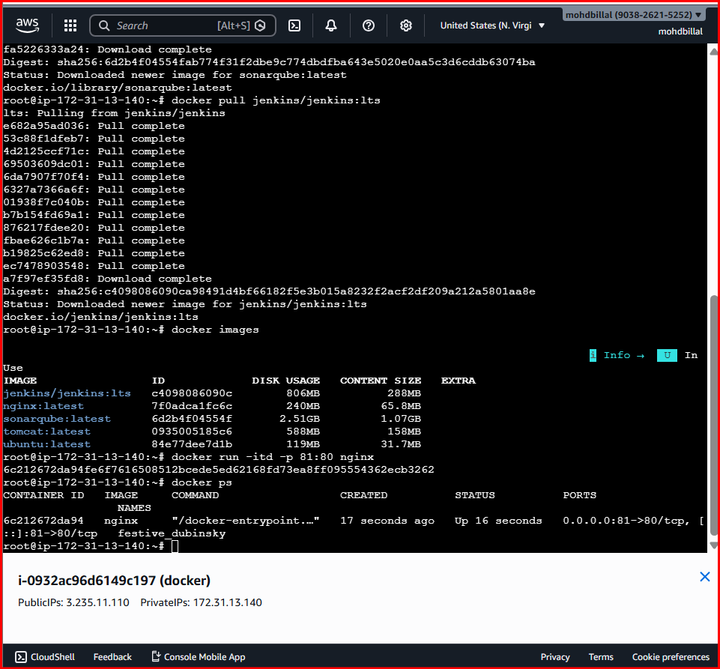
- With the public ip verify on browser

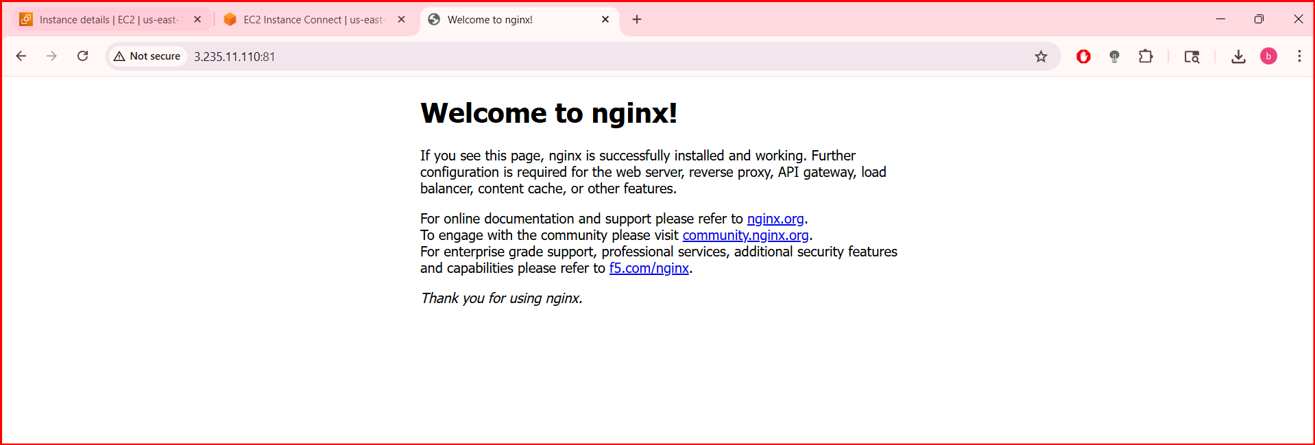
5) Delete the apache tomcat image from local.

- Delete the apache tomcat image from local.
- Use the command docker image rmi tomcat to delete the image

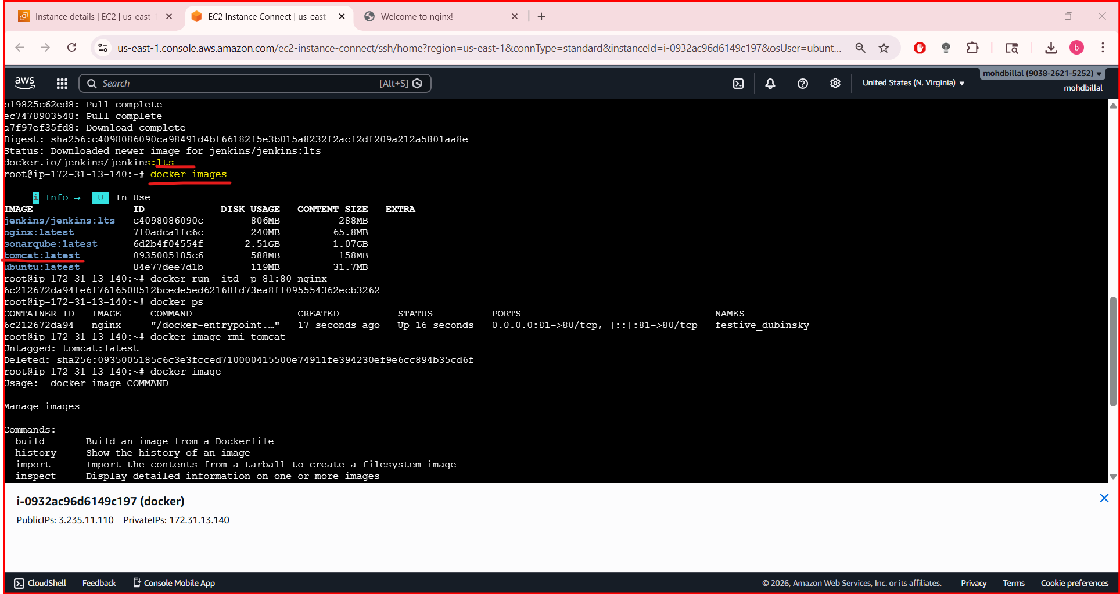
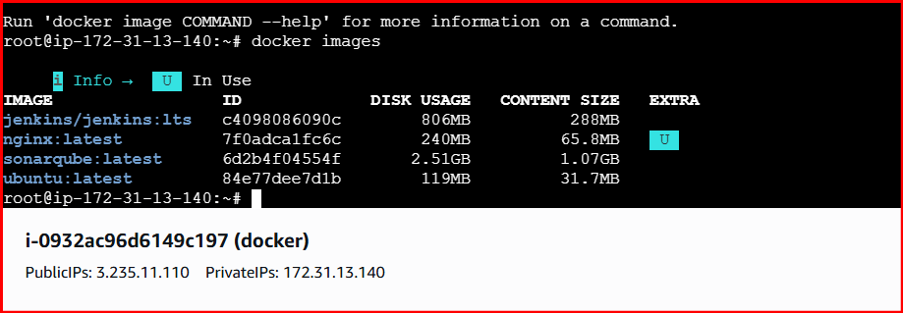
6) Inspect the jenkins image,sonarqube image.

- Inspect the jenkins image,sonarqube image
- Use the command inspect to get all the details of the images

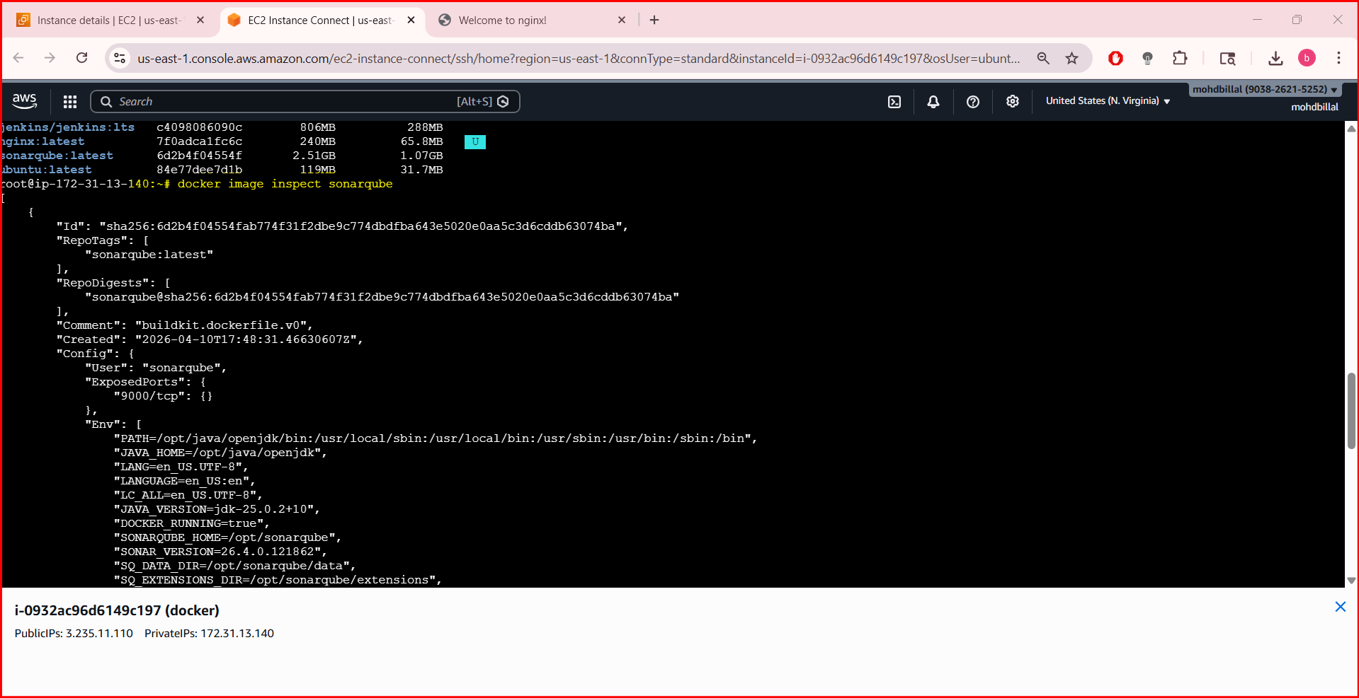
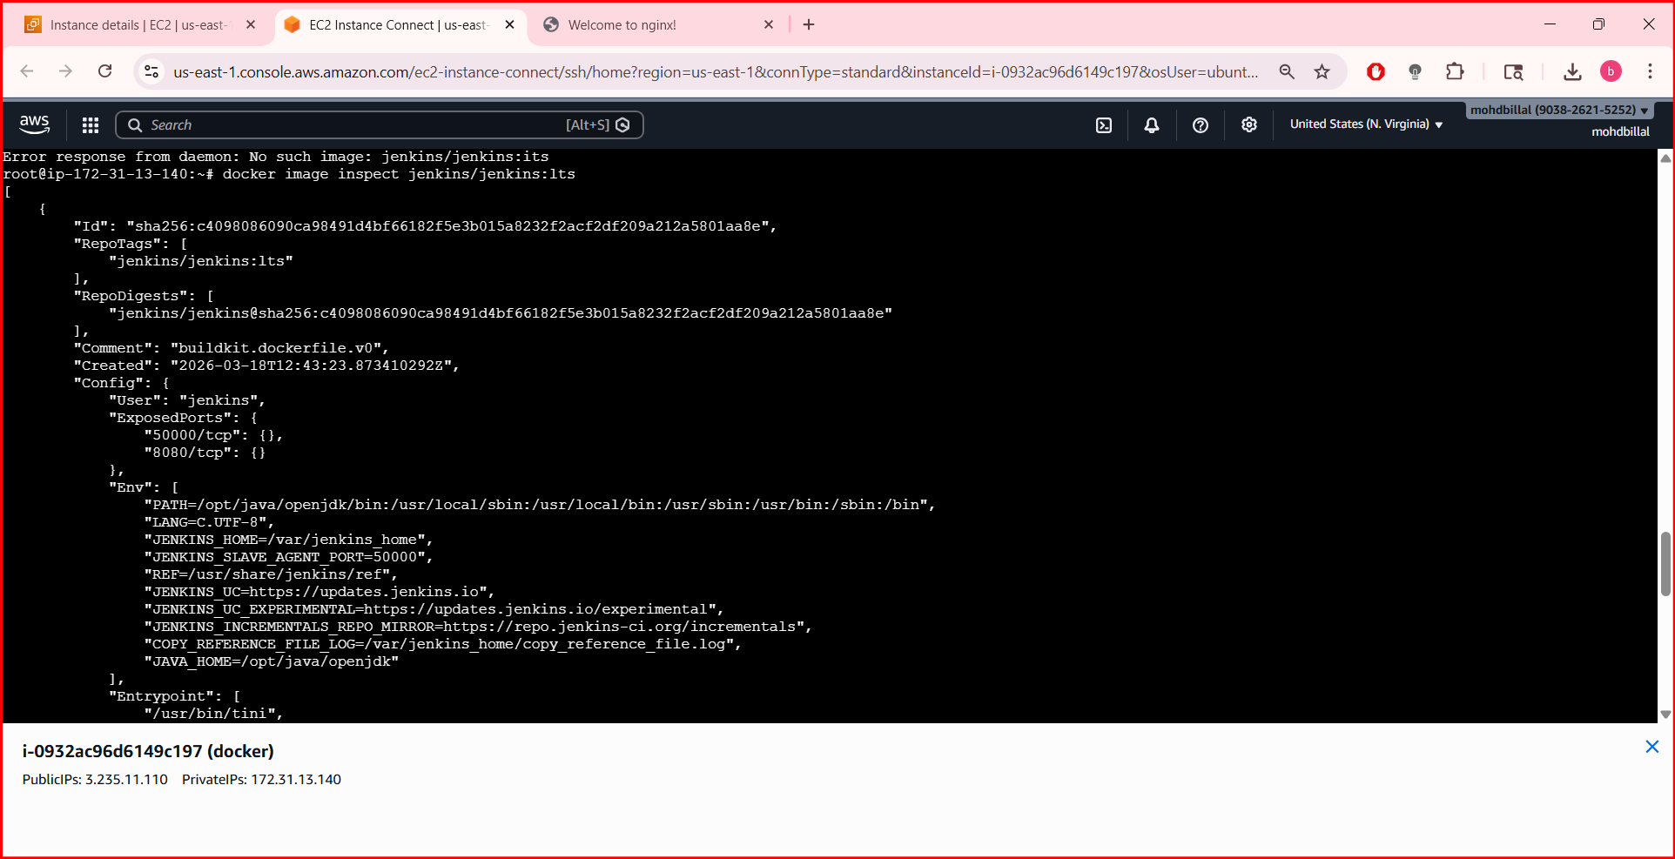
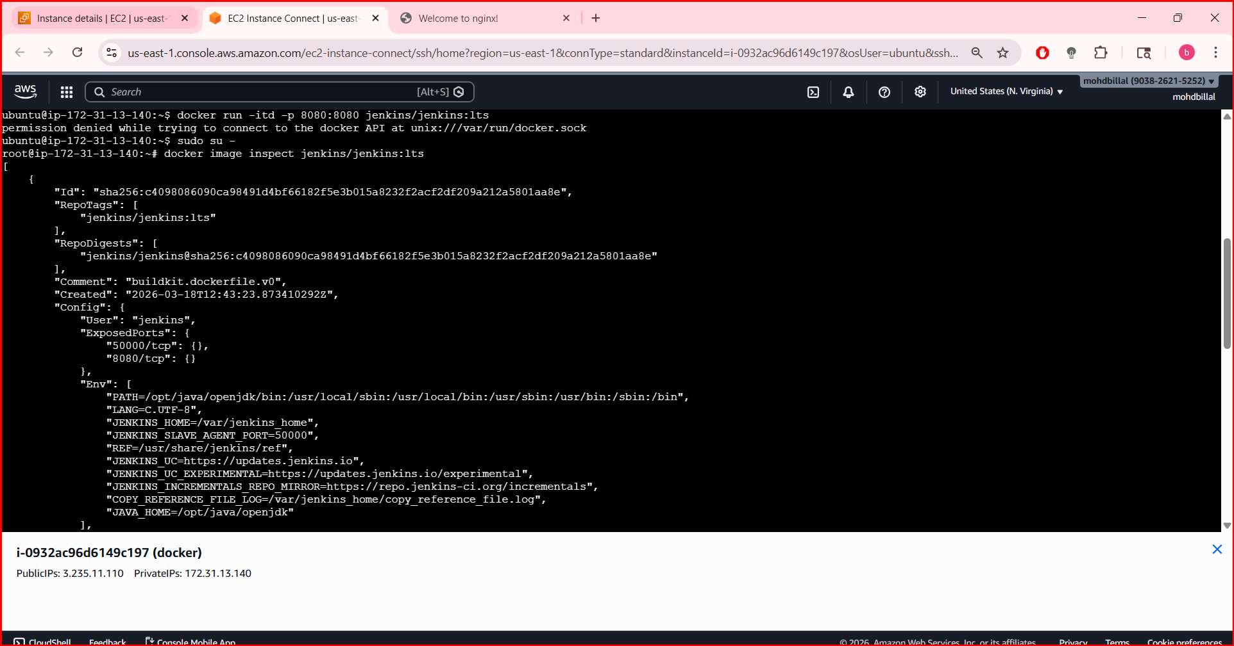

- Run jenkins contianer and run one sample job
- Run the Jenkins image and access on browser
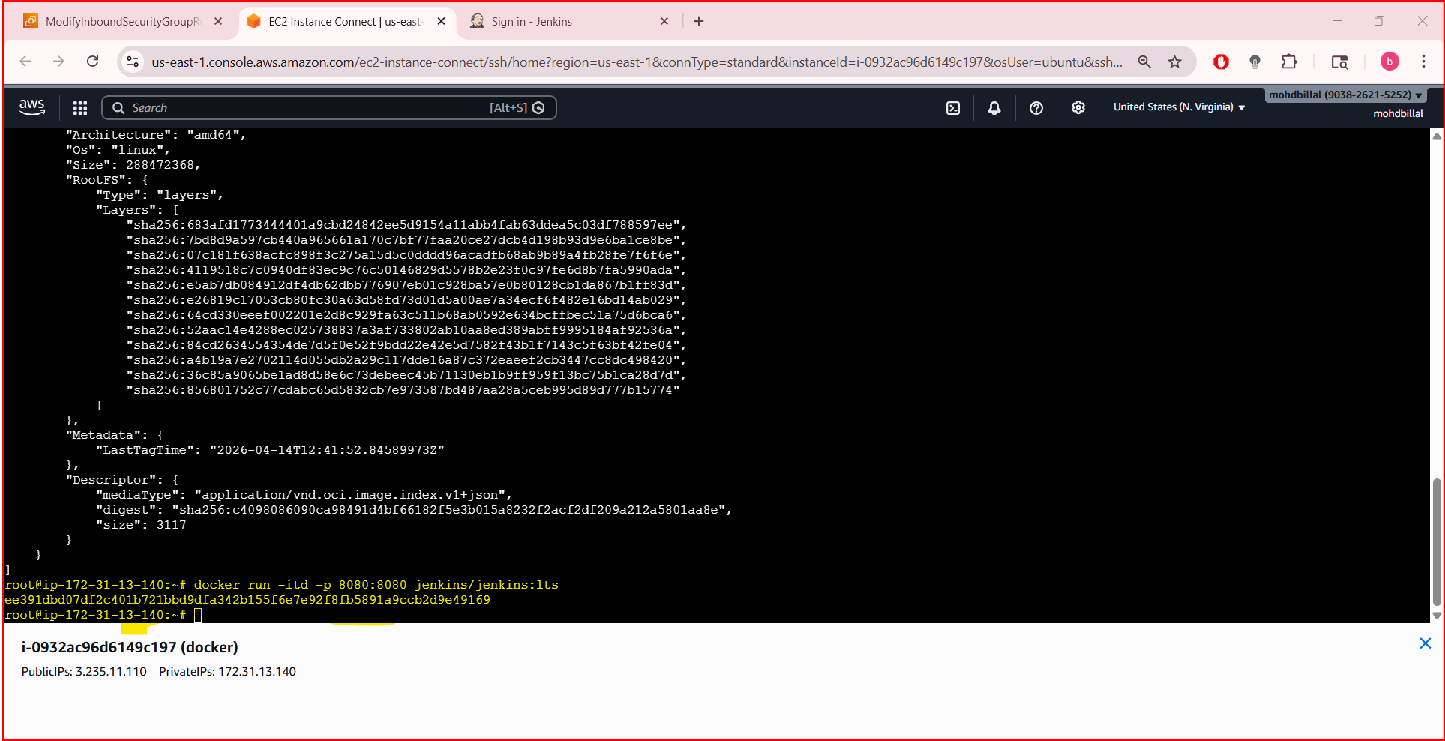
For initial password execute the command
docker exec <container id> cat /var/jenkins_home/secrets/initialAdminPassword

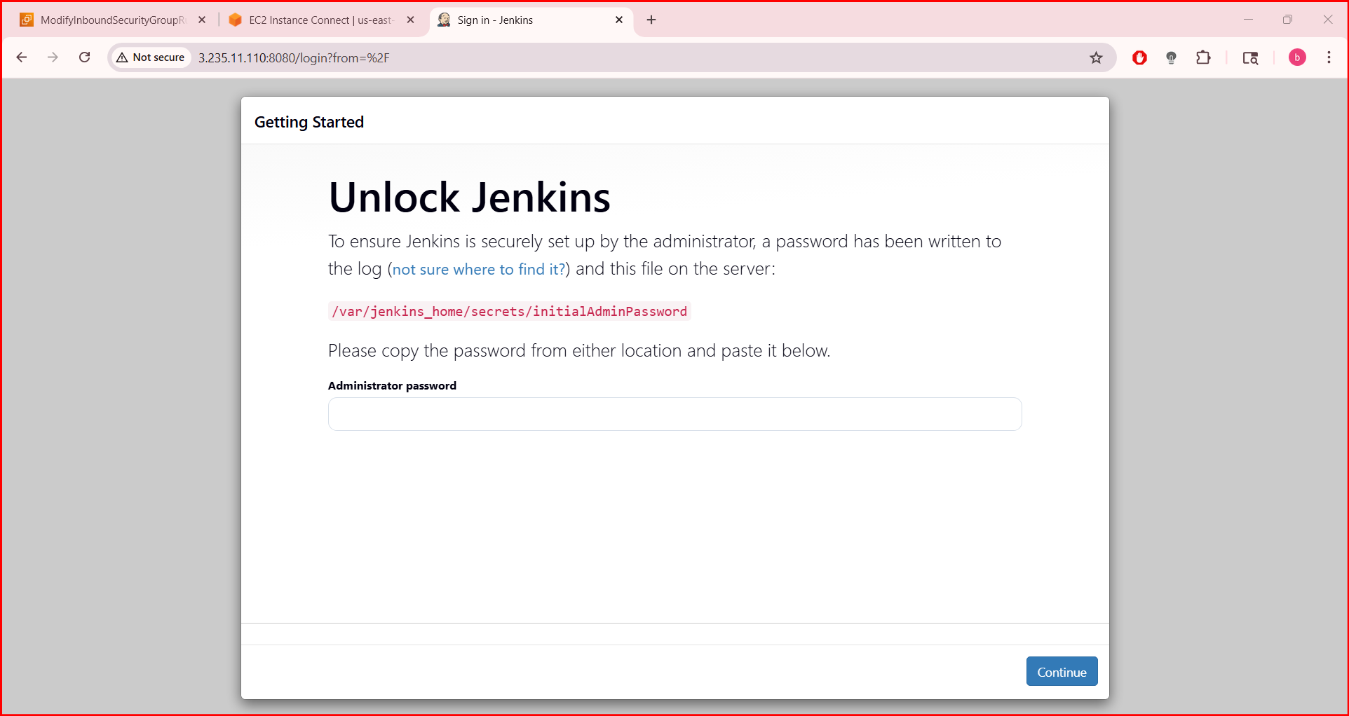
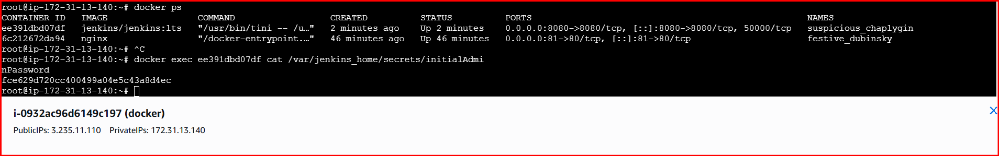
7) Run jenkins contianer and run one sample job.

Click on create a job

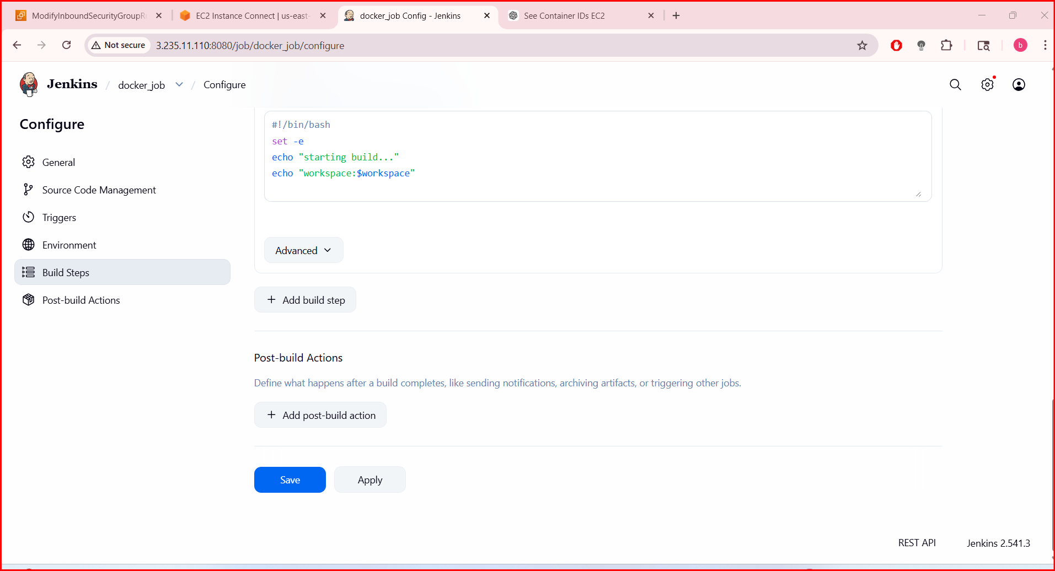
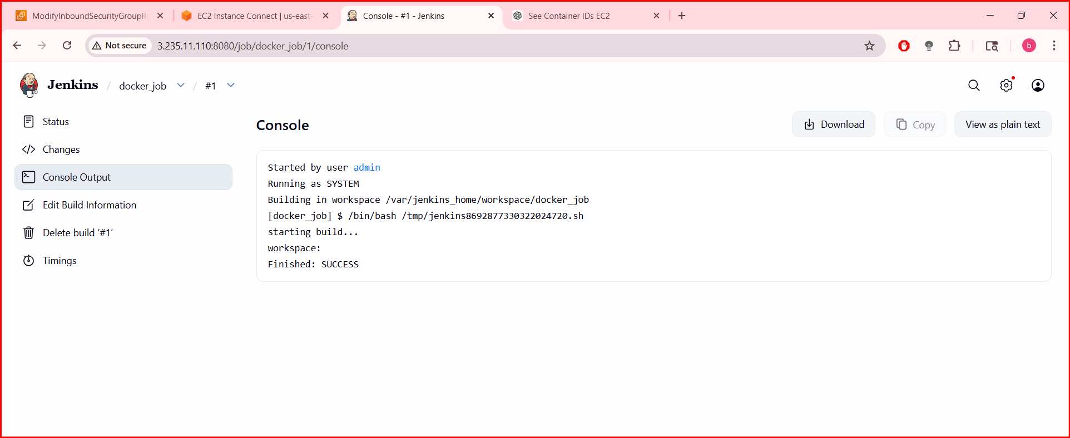
Syntax:
#!/bin/bash
set -e

echo "Starting build..."
echo "Workspace: $WORKSPACE"
echo "Build number: $BUILD_NUMBER"

# Basic commands
date
uname -a
whoami

echo "Build completed"

